**Evaluation of the Indian Taxi Market:**

The taxi space in India is heating up and has been seeing a phenomenal growth in the past 6-7 years. Over $400 Mn (INR 2400 Crores) of Venture Capital money has been pumped in into these companies in the past 4 years itself.

Ola cabs recently raised over $ 210 Mn in Series D from Softbank at a valuation of over $1 Bn to focus on expansion. TaxiforSure also raised over $30 Mn in its latest round while Uber has a warchest of over $1.5 Bn to fuel its international expansion. Uber has also committed almost $400 Mn to grow and promote its service in India.

The Indian radio taxi market alone is pegged anywhere between $6-$9 billion dollars by different estimates, and is forecasted to grow at 17-20% annually. More importantly, the organised taxi market is still minuscule as compared to rest of the taxi market in India; it constitutes only 4-5% of the market in terms of sheer number of vehicles. The rest is by operators who own fleets of 2-50 cars and typically have a presence in 1 or 2 cities.

## Market1.jpg

With this in perspective one can now see why each player is trying to aggressively expand and is raising such humungous funding rounds. The aggregators like Ola, Uber and TaxiforSure have just conquered less than 3-4% of the total available market of India so far and have a huge opportunity in front of them.

**Growth Potential:**

Growth may be achieved by:

* Geography: The user base may be expanded by shifting the marketing emphasis/campaigns from one country to another. Keeping in mind that the user base can grow beyond the GCC/MENAT region.
* Additional Features: Other features could be added, such as allowing the Passenger to select a Taxi with a handicap chair, baby-seat, A/C, etc.
* Overcoming the Language Barrier: Since most individual Taxi Drivers in the GCC/MENAT region and Taxi Companies in the GCC region have a weak command of English, having the app in English language and eventually in other languages will offer a bigger user base.
* Passenger Loyalty: We can create loyalty by offering discounts for repetitive app using passengers. Such discounts will have to be negotiated with Taxi Companies.

**Marketing:**

The marketing routes to be used are:

* Blogs
* Posting a demo video on YouTube
* Mass email marketing
* SEO and app store optimization
* Increasing visibility on social media
* Apply for awards
* Run a contest
* Recruit users manually
* Get speaking opportunities

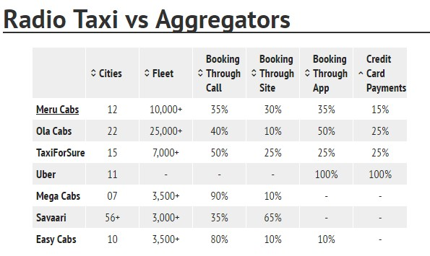

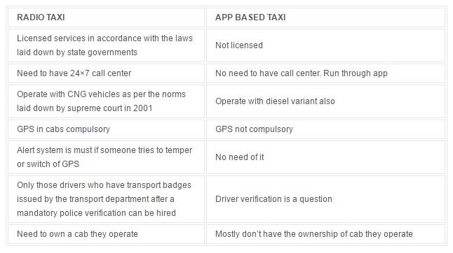

While the aggregator taxi services like Ola and Uber stared out many years after the traditional radio taxis like Meru & Mega Cabs, they’ve already started to eclipse them in terms of city coverage, fleet size, offerings and pricing. Now we go deeper into the aggregators and see how they fare against each other.

**Beginning of Uber, Ola and TFS:**

* **2010**

Ola cabs started its operations in 2010 from Mumbai under the name of ANI Technologies Pvt. Ltd.

* **2011**

TaxiForSure.com started its operation in 2011 from Bangalore under the name of Serendipity Infolabs Pvt. Ltd.

* **2013**

Uber started its operations in India in 2013 starting from Bangalore, but the parent company operates under Uber Technologies Inc, incorporated in the state of Delaware, US.

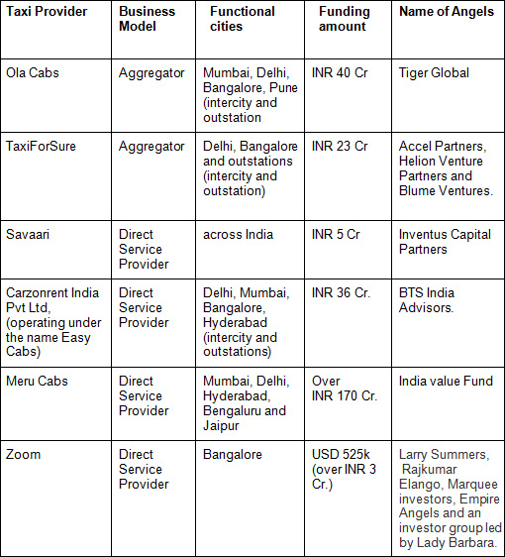

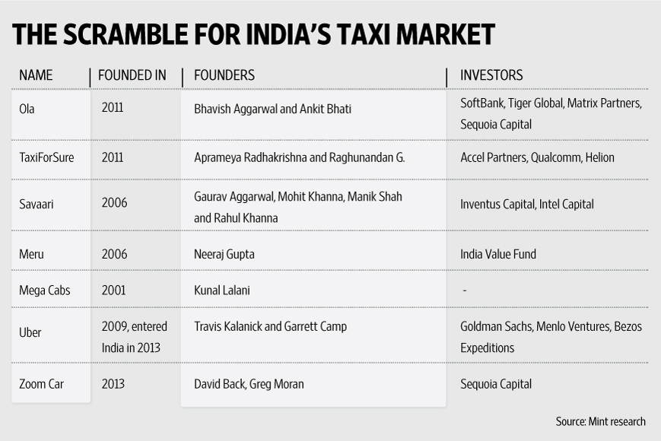

**OLA Cabs:**

In the middle of many cab companies, Ola Cab Company is the one that has made a good hit in the market of India. Many people much attracted and excited towards Ola cabs to travel within and outside the cities. Passengers can travel with great comfort and safety with affordable tariff and charges. The central headquarters of Ola is in Bangalore, having its branches in Mumbai and Delhi. It also has regional offices in all those cities in which Ola cabs are running. One can book an Ola cab with ease by making use of the Ola app available for all mobile users at any time. It offers to book even on the web browser; bookings can be both cash or cashless.

Ola provides these types of car to their customers:

1. Ola Prime
2. Ola Sedan
3. Ola Mini
4. Ola Pink
5. Ola Autos(Auto-Rickshaw)

**How to give a car to Ola cabs?**

Attaching a car to the Ola Cabs is an easy procedure; all you need to do is to make a call to the Ola customer care centre. They furnish you with all the details and information to be known and followed to attach your car to the Ola Company. But pursue to join the company after going through all the related terms and conditions which are applicable before attaching your car to cabs company. Also, you must be conscious that different cab types have different charges and offers in various cities.  
To Register with Ola Cabs or to start the business with them you need to contact them from below.

1. First, you need to call to your nearest regional office, or you can directly call to the main branch for new registration of your car.
2. You need to submit your required documents to the company.
3. You car should be in good condition as you need to show pictures of your car situation to the ola company or staffs will see your car condition in your nearest regional office.
4. After all, these you will get new smart phone featured with Ola app on it.
5. Staffs will make you learn all the guidelines, steps, offers, etc
6. After all, these you need to open a current bank account.
7. Within a week, you can run your car as an Ola Cab in your city.

**Money & Bonuses Ola Cabs Pay:**

On completing a single ride, Ola company takes only 10% of commission on the total amount of bill which will be calculated by Ola app itself. Ola also provides bonuses which are given down below

Peak Hour Timing : (7 am to 12:30 pm and 5 pm to 11 pm are considered as peak hours)

* **Bonus On-Peak Hours** – Whenever you complete any ride on peak hours then you will be awarded 250INR to your account as a bonus, and it depends on you how much you complete ride on peak hours.For each ride 250INR as the bonus on peak hours.
* **Bonuses On Airport Drop –**Whenever you drop a customer to an airport then you will be awarded 800INR to your account.
* **Bonuses on 12 Ride Completing –** Whenever you complete 12 rides in a single day then you will get the 4500INR bonus in your account.

Note: Bonus may vary time to time, and you will get all the details about it at the time when you attach your cars with ola company. Ola cabs will give you all the details about it.

OLA Cabs is India's first aggregator of car rentals and point to point

cab services.

**OLA BUSINESS MODEL -** They partner with private taxi owners, provide modern technology and processes for booking,

dispatch etc. and quality assurance. Cab booking Startups like OLA requires very low capital investment as they don’t buy cars. Private taxi owners also benefit by being able to access aggregated consumer demand across different services like outstation travel, local transfers and full day/half day rentals.

**OLA Mini Charges for an A/C Cab -** Rs 13 per km but with a base fare of Rs 100 for the first 6 kms.

**OLA Cabs Revenue Model -** Runs on a pay for performance model. OLA charges a commission in whatever sales they make. Also to get access to the technology platform, OLA charge taxi owners a small fee.

**Whats's the differentiator between OLA and other Cab booking companies?**

OLA Cab understood that Cash is the most preferred way in India to transact and a person to talk to on the other end is important to them. A wider choice of categories, booking modes, payment options etc. makes Ola cabs the preferred choice for the Indian customer

**What's OLA's USP in Car Rental space?**

* Providing price transparency
* Give customers a standardized experience across all types of cab requirements be it local or outstation.

**How does OLA run their car rental services?**

Ola cabs has its apps, call center, outstation hires, city taxi and half/full day rentals.

**How many private taxis are there all across India?**

4,00,000

**OLA Cab Services**

Ola Mini

Ola Prime

Ola Luxury

SWOT Analysis of Ola Cabs with USP, Competition, STP (Segmentation, Targeting, Positioning) - Marketing Analysis

|  |  |
| --- | --- |
| **Ola Cabs** | |
| **Parent Company** | ANI Technologies Pvt Ltd |
| **Category** | Service provider for taxi hiring (Aggregator) |
| **Sector** | Transport & Logistics |
| **Tagline/ Slogan** | *Chalo Niklo* |
| **USP** | Standardized customer experience & Price transparency |
| **STP** | |
| **Segment** | People who mobile from one place to another for any purpose |
| **Target Group** | Customers who are in need of cabs instantly |
| **Positioning** | Using technology to bring the higher efficiency and customer experience |
| **SWOT Analysis** | |
| **Strengths** | 1. First mover advantage as a taxi aggregator in India  2. Acquisition of Taxi For Sure made it No. 1 in India  3. Top of the mind service  4. High awareness due to aggressive TV, online and print media marketing  5.Huge customer base & due to network effect it is increasing  6. Rapid expansion and online application  7. Multiple rounds of VC investments have made the brand financially strong |
| **Weaknesses** | 1. Drivers are the face of the company and hence their misbehavior directly affects the brand image  2. While the demand is huge, amount of cash burning is huge and monetization is very difficult |
| **Opportunities** | 1. Unorganized market is huge (~90%) and hence potential is high  2.Increasing internet penetration & smart phone users  3. Rising disposable income  4. Shifting of consumers towards convenience creates huge demand  5. Acquisition of smaller players |
| **Threats** | 1. Rising competition  2. Uber has deep pocket and hence can burn cash heavily  3. Presence of many national players  4. Absence of clear government regulations in developing countries  5. Future is unclear due to lack of regulations and Customer loyalty is less in this industry |
| **Competition** | |
| **Competitors** | 1. Uber Cabs  2. Meru cabs (India)  3. Easycabs  4. Unorganized players (Auto rickshaws/Taxis)  5. Carpooling services |

**TaxiforSure Cabs**

SWOT Analysis of Taxi For Sure with USP, Competition, STP (Segmentation, Targeting, Positioning) - Marketing Analysis

|  |  |
| --- | --- |
| **Taxi For Sure** | |
| **Parent Company** | ANI Technologies Pvt Ltd |
| **Category** | Service provider for taxi hiring (Aggregator) |
| **Sector** | Transport |
| **Tagline/ Slogan** | U drink V drive; Your Taxi has arrived |
| **USP** | Reliable taxi ride ‘for sure’ |
| **STP** | |
| **Segment** | People who mobile from one place to another for any purpose |
| **Target Group** | Customers who are in need of cabs instantly |
| **Positioning** | Experience, Economical & Convenience |
| **SWOT Analysis** | |
| **Strengths** | 1. Only service provider with operator based model  2. Operators have better control over drivers  3. Early mover advantage  4. First into NANO service & it has huge potential  5. Rapid expansion  6. Employees are from well reputed institutions compared to its competitors  7. Acquisition by Ola means more financial stability and better reach |
| **Weaknesses** | 1. Drivers are the face of the company and hence their misbehavior directly affects the brand image  2. While the demand is huge, amount of cash burning is huge and monetization is very difficult currently |
| **Opportunities** | 1. Unorganized market is huge (~90%) and hence potential is high  2. Increasing internet penetration & smart phone users  3. Rising disposable income  4. Shifting of consumers towards convenience creates huge demand |
| **Threats** | 1. Rising competition  2. Presence of many national players  3. Absence of clear government regulations in developing countries  4. Customer loyalty is less in this industry |
| **Competition** | |
| **Competitors** | 1. Uber Cabs  2. Meru cabs(India)  3. Easycabs  4. Unorganized players (Auto rickshaws/Taxis)  5. Carpooling services |

**Meru Cabs**

SWOT Analysis of Meru Cabs with USP, Competition, STP (Segmentation, Targeting, Positioning) - Marketing Analysis

|  |  |
| --- | --- |
| **Meru Cabs** | |
| **Parent Company** | Meru Cab Company Pvt. Ltd |
| **Category** | Taxi Service provider |
| **Sector** | Transport & Logistics |
| **Tagline/ Slogan** | Rely on us |
| **USP** | Transparent pricing structure and the Meru training academy |
| **STP** | |
| **Segment** | People who mobile from one place to another for any purpose |
| **Target Group** | Customers who are in need of cabs instantly |
| **Positioning** | India’s No. 1 Radio Cab Service |
| **SWOT Analysis** | |
| **Strengths** | 1. First mover advantage as a radio taxi operator  2. High awareness as a taxi operator  3.Presence across many cities across India  4. Trained drivers with good condition of cars with safety of prime importance, who are taught at the Meru training academy  5. Meru Cabs was one of the first companies to launch metered "Radio cabs  6. Available 24x7 with e-bill services for the customers  7. Serves over 2 million customers and has been recognized with several awards |
| **Weaknesses** | 1. As per their business model, it owns taxis and hence fixed investment is high  2. Sudden surge in competition means limited margins and lower market share |
| **Opportunities** | 1. Unorganized market in India is huge (~90%) and hence potential is high  2. Increasing internet penetration & smart phone users  3. Rising disposable income  4. Shifting of consumers towards convenience creates huge demand |
| **Threats** | 1. Rising competition  2. Uber & ola cabs have deep pocket and hence can burn cash heavily  3. Presence of many national players  4. Absence of clear government regulations in developing countries  5. Future is unclear due to lack of regulations and Customer loyalty is less in this industry |
| **Competition** | |
| **Competitors** | 1. Uber Cabs  2. Ola cabs  3. Easycabs  4. Unorganized players (Auto rickshaws/Taxis)  5. Carpooling services |

**Uber Cabs**

Uber is also one of the top leading cab company. Which is at presently available in 11 biggest cities of India. Uber Cabs had value above $50 billion that’s why uber comes under the world’s top cab company. It has spread out its coverage not just within the country but also in the worldwide as it reaches almost all countries to start their cabs business. In India uber began taking cash payment also as per demand by Indian publics but it is in trial mode now and available only in few cities of India, it is something which is never happened before globally. If this trial mode makes uber company increase their business in India, then they will apply for cash payment in all cities. When we tested all cabs company regarding in profit, then we found that uber is much profitable than any other cabs company. It gives you much bonus then Ola and taxi for sure in peak time that’s why it is much famous and premium as compared to other cabs company. To apply on Uber cabs requirement is same as Ola cabs & taxi for sure.

### Uber Founders, Funding received and Timeline:

**Founders**: Travis Kalanick and Garrett Camp.

**Company Headquarters**: San Francisco, California, United States.

**Funding received by Uber**: $8.2 Billion

**Company Valuation**: Over $51 Billion

**Number of Users**: More than 8 Million

**Number of registered drivers**: 1,60,000

**Number of new driver sign-ups**: 50,000 every month.

**Average number of daily Uber Trips**: 1 Million

**Uber Successful Timeline:**

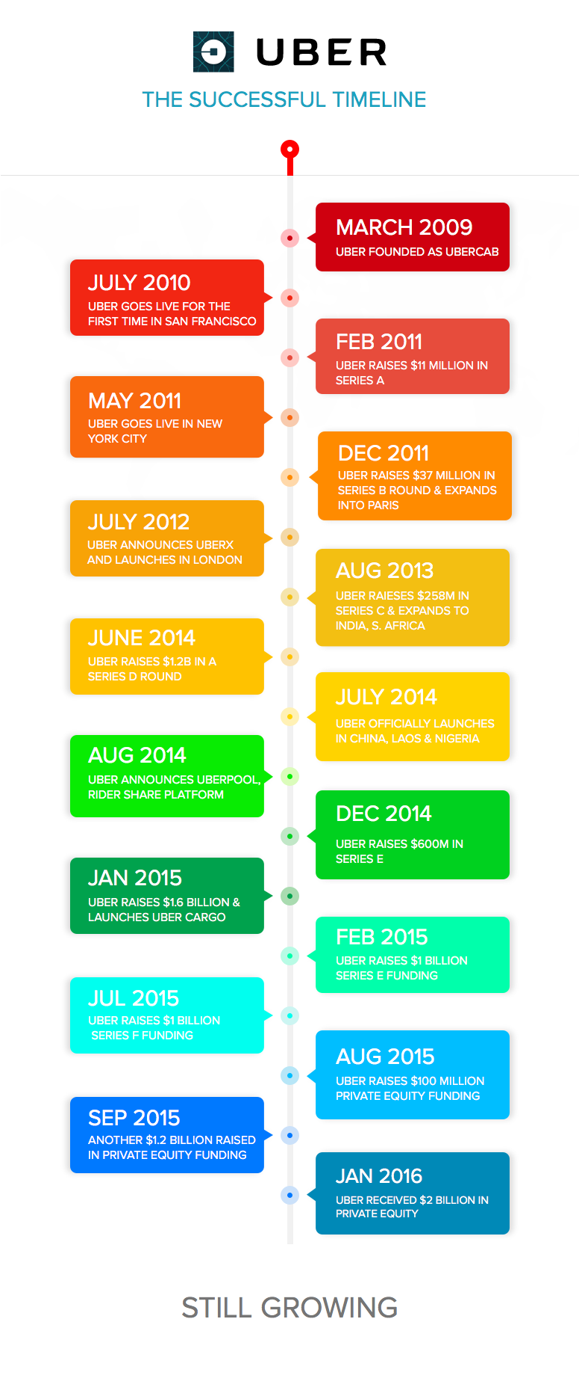

### Uber’s Revenue Generation Model:

If you have ever travelled in a taxi, you might have paid the driver in cash at the end of your journey. The cash collected by each journey is the only source of revenue for a traditional cab company. Uber is no different. Neither does Uber have a different revenue model than the one mentioned above nor it has any other source of revenue as of now. But just imagine 1 million rides a day. It will help you calculate those big numbers that Uber earns. Let’s dig a little deeper to understand Uber’s source of income.

What has made Uber so successful is the fact that the revenue model of Uber is as unique as their business model. It can be explained as:

**1. Different cab models to cater to everyone**:

Uber has not limited itself to a particular segment of cars or to a particular segment of people. There is Uber X, Uber Black for those who love to travel in a black car, Uber Taxi for those looking for cost-efficient solutions and Uber SUV for those who want luxury.

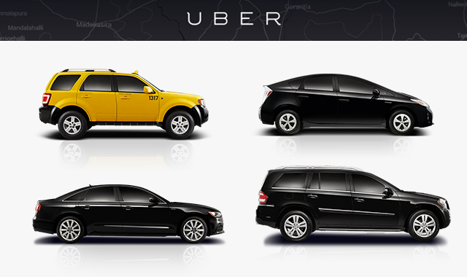

**2. Surge Pricing Technology**:

Variation in cab fares according to situation is an important aspect of Uber’s business model. Whenever the demand increases, per mile prices are automatically increased. The new price depends on the number of available drivers and the number of requests made by people who want to travel. Uber has applied for a [price surge technology](http://time.com/3633469/uber-surge-pricing/) patent in the US.

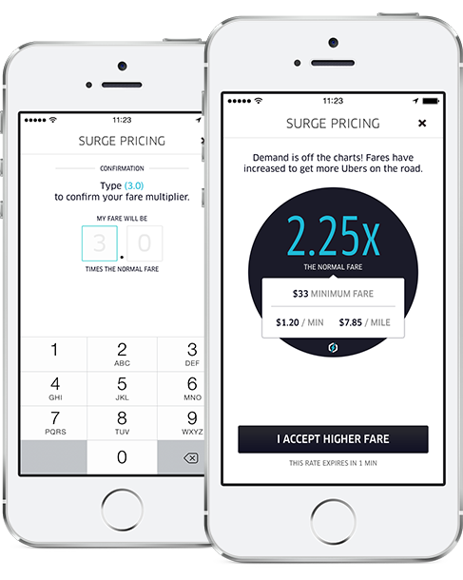

**3.**  **Other Uber rides**:

Uber has come a long way from cabs. It now offers boats, helicopters as well as some other transportation means on demand. Uber recently launched a motor­cycle-pickup service in Paris, a delivery service in San Francisco, and an ice-cream-truck-delivery service in 7 other cities. However, these means are available in selected geographical locations but it has led Uber to add new streams of revenue into its business model.

**Features of Uber**

* A user can tap his smartphone and call a cab at his location.
* The driver has the option to accept or reject a ride.
* If driver accepts the ride, driver details are sent to the customer along with ETA.
* The customer can track the driver as he arrives to his location.
* The driver can also track the exact location of the customer and reach his exact location.
* The payment procedure is handled by Uber.
* In some countries like India, Uber has even started accepting cash payments which are paid directly to the driver.
* Uber business model had a rating system in place for drivers right from beginning, where a customer can rate the driver after his ride.

**Value Propositions**

**Customers:**

* No need to wait for a taxi for long times.
* Free rides on certain occasions and discounts from time to time.
* Prices lesser than the normal taxi fares.
* Uber’s tagline says – Your personal driver. It lets customers travel in style.
* Fixed prices for common places like Airport etc.

**Drivers:**

* Additional source of income.
* Flexible working schedules. Can work part time or simply whenever they like.
* Easy payment procedure.
* Those who love to drive can earn money while pursuing their hobby.
* Uber pays drivers to be online, even if they don’t get any request.

**Customer Segments**

Customers for Uber are those who:

* Do not own a car.
* Do not want to drive themselves to a party or function.
* Like to travel in style and want to be treated as a VIP.
* Want a cost-efficient cab at their doorstep.

Uber has such a vast customer segment that it has got something on offer for everyone. From Uber Taxis to Uber Black and from Uber X to Uber SUV, the company has got a vast range for its customers to make a choice.

Uber serves professionals as they hire an Uber cab to and fro work. For this Uber did few tie-ups with corporates in the beginning and does so when it launches in a new city in a new country. Apart from professionals, Uber tries to touch hearts of people by offering special services like:

**Uber for Kids**: A special service from Uber dedicated for parents who want their kids to reach home from school in an Uber cab.

**Uber for Senior Citizens**: Another special service from Uber where it targets senior citizens. As per the statistics, Senior citizens make for upto 30% to 40% of total rides in many cities. This made Uber have some special features for seniors and hence attract more senior citizens on the platform. [Check out this post from fortune: Why senior citizens are flocking to Uber](http://www.forbes.com/sites/harrycampbell/2015/07/23/why-senior-citizens-are-flocking-to-uber/).

All this might raise another question in your mind. The question about how does Uber find them or how does it market out to its target audience? We extended our research beyond Uber business model and came up with an entire growth model of Uber.

**Growth Model: How Uber finds customers**

In less than 6 years, Uber has managed to become the best example of a city-by-city mobile service company roll-out. Many generic pointers that I talked about in this Blog Post regarding scaling User Acquisition efforts for On Demand platforms borrows elements right from Uber’s playbook.

Let’s try to decode Uber’s Playbook and how it plays out as it launches in a new city or a country:

The underlying principle here is that for every city it launches, it faces the same chicken and egg problem. The advantages that Uber has as compared to new startups in this space are:

1. Lot of money to incentivize both drivers and customers.
2. Rock solid processes or playbooks that have evolved through experience launching Uber in 311 cities till date.
3. Already known brand that gets early curious adopters.

Everything starts with a small city launch team. Every city has a general manager who heads the customer acquisition as well as driver acquisition. The first cabs to come on board are generally professional drivers who are already associated with local taxi companies and have their own cars.

First customers come from various local [advertising channels](http://www.entrepreneur.com/article/239499) like FM radio, newspapers, online advertising etc. Uber is such a large name that people are already waiting for the cab company to start services in their city.

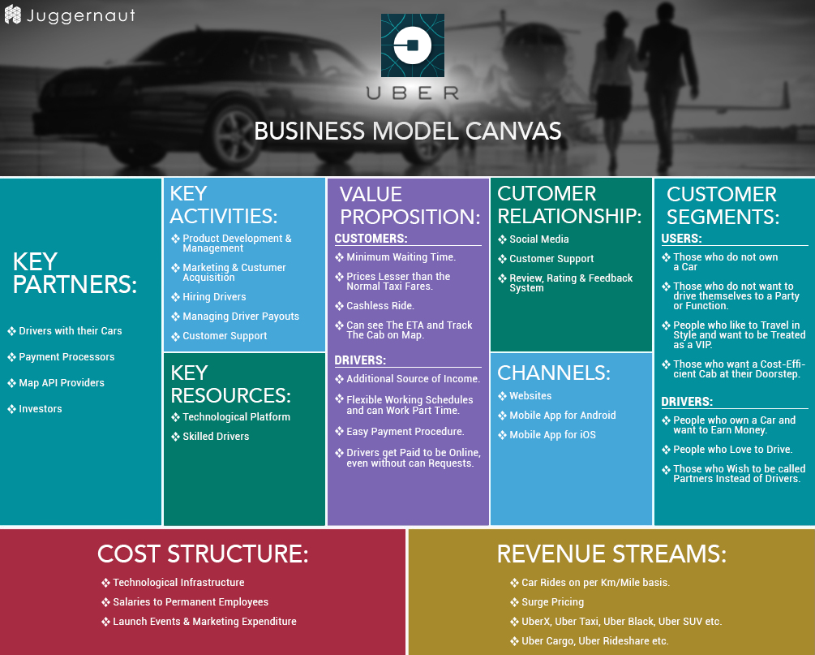

**4 step model about how Uber works**

* **Step 1 (Request a cab):** The first step in the business model of uber is about creating a demand. People have a smartphone app which lets them request a cab instantly or schedule it for some time later.
* **Step 2 (Matching):** As soon as the request is made, a notification about your details is sent to the nearest driver. Cab driver has the option to accept or reject the ride. In case he rejects, notification is sent to another driver in that area.
* **Step 3 (Ride):**Customer can track the cab when it is arriving and the ETA is also shown to the customer. The meter starts as soon as the customer sits in the cab which can be tracked through the customer side app as well. Friendly drivers make sure that the ride is comfortable for the passenger.
* **Step 4 (Payment & Rating):**Once the ride is over, customer gets an option to rate the driver. Rating system is an important part of Uber’s business model as it lets a person know about the driver before booking a ride and helps him trust the driver.

**How and Why Uber became so successful:**

Uber’s business and revenue model just can’t be stated as complete if this widely asked question about Uber’s successful journey is not answered. There were certain factors that led to Uber’s success. Here’s a brief journey that Uber went through when it launched. Similar journey can be followed by any startup which aims to make it as big as uber.

**The problem with local Taxis**

Earlier, people had to stand on the street side and wave their hand in order to signal a taxi to stop. The wait time, the inconvenience and high rates were a problem for everyone. Quite a few taxis were available and drivers / taxi companies used to charge whatever they thought was right. There was no control on prices and people were left with no other option. Apart from this, the situation was worse during the peak hours as it was quite hard to find an empty cab.

**The launch of Uber**

Uber recognised the ongoing problem in regard to booking a taxi and gave a technological solution through a mobile app. The solution to book a cab by tapping a smartphone brought a revolution in the taxi industry. Uber app was officially launched in 2010 and soon became popular due to the value it provided to people.

**The early adopters**

It is quite difficult to market a newly launched product or service in any geographical area. What gave uber the edge is that it launched in San Francisco, a city which is home to tech savvy people. The first drivers on the platform came through cold calling. Many of them were professional drivers with other cab companies or were self employed as a taxi driver.

To get their first customers, Uber took to social media and other mass marketing means. It offered discounts, free rides and rates that were too less as compared to other cab services in the city. The first customers for Uber were those who enthusiastically wanted to try the new service. Uber offered rides from club venues to user’s doorstep so the party people were amazed. It offered rides to the corporate sector who worked in offices helping them to save time.

**Word of Mouth advertising**

Whosoever took a ride in Uber was baffled by the first hand experience. This made the early users to become regular customers and they also helped spread the name by word of mouth advertising. This word of mouth advertising was one of the major driving force

**Main Growth opportunities tapped by Uber**

1. Party people who go to clubs, parties or events.
2. Business Travellers and Tourists.
3. Cab at doorstep in bad weather conditions.
4. City’s Nightlife.

**Problems Uber still faces**

**Lawsuits**: Uber has pending lawsuits in courts of New York and San Francisco. According to Uber, all drivers working for it are its partners while the court says that they are employees. Uber is not the only company facing such a problem but in fact almost all companies who hire 1099 workforce are under the scanner.

**Chicken & Egg problem (New city Launch)**: Uber faces the chicken and egg problem whenever it launches in a new city. Acquisition of customers as well as partnering with new drivers is not an easy task. To solve this problem, a marketing team starts working in the new city by reaching out to professional drivers. Soon, online and offline marketing is initiated. Discounts are always the main USP to woo customers in the starting stage. Read – [How to solve the chicken and egg problem](http://nextjuggernaut.com/blog/how-to-solve-the-chicken-and-egg-problem/).

**Trust and Safety Issues:** There have been cases where Uber drivers have acted rude to passengers. Some cases where Uber drivers have outraged the modesty of female passengers have come to the limelight. This is a big challenge for Uber. Although the company takes all steps such as police verification of drivers and their ID details but still such cases cannot be ruled out completely.

**Takeaways from Uber Business Model**

* Go for less ownership model. Uber does not own any cab but still provides over 1 million rides a day through its partner network.
* Choose an industry. Think about the most common problem it has. Find a solution and disrupt the existing model through technological infrastructure. That is what Uber did in the cab industry.
* Treat your initial users as kings. They are really important for the growth of your business.
* Expand step by step. Do not add everything in your business model in the first go. Uber started with cabs but now even has boats, helicopters, bikes and other means.
* Opportunity won’t come to you. You have to look for them. Uber created an opportunity by offering discounted rides for particular events / party venues and hence got its first customers.
* Treat your workforce an important part of your business. Uber calls its drivers as partners and gives them a decent 80% of the total fare.

**Not taken any ride with Uber yet and looking for a free ride?**

If you not taken any ride with Uber yet, then you can get free ride by just using this **promo code: xxxxxx**

Steps to follow to get a free ride by uber:-

1. Install the uber app from your android play store or apple’s iTunes store.
2. After installing the app, you need to create an account by registering on it.
3. After registering on it then go to promotion option and put this *promo code: xxxxxx .*
4. After putting this promo code, you will get one free ride of worth 150INR.
5. Get your free ride now.

## Uber Cabs have these categories:

1. UberGo ( Mini)
2. UberX (sedan)
3. UberBlack (luxury version of UberX)

## How to Attach Cars with Uber:

1. First, you need to call to your nearest regional office, or you can directly call to the main branch for new registration of your car. Also, you can register your car for Uber cabs business from their official website where you can attach your car with uber.
2. You need to submit your required documents to the company.
3. You car should be in good condition as you need to show pictures of your car condition to the Uber company or staffs will see your car condition in your nearest regional office.
4. After all, these you will get new smartphone featuring the uber app on it.
5. Staffs will make you learn all the guidelines, steps, offers, etc
6. After all, these you need to open a current bank account.
7. Within a week, you can run your car as an Uber Cab in your city.

## Uber Cabs Requirement:

Required Documents to attach your car with Uber cabs are:-

1. One of the most important document is driving license which is required at very first.
2. You need latest police verification, or Delhi PSV Badge is required as per the guidelines of uber cabs.
3. Insurance Paper is required.
4. Permit.
5. Rc and one canceled cheque.

## How Much Money & Bonuses Uber Cabs Pay:

If we talk about uber’s payment system then uber is the one who pay more bonuses then any other cabs company in India. They send the payment every week (on Monday), and they have excellent bonuses system. Uber Cabs deduct 20% of commission from the total fare. All the bonuses have been listed down below.

Peak Hour Timing: (7 am to 12:30 pm and 5 pm to 11 pm are considered as peak hours)

* Bonus on Peak Hour: You will get 250INR on completing any ride in peak hours.
* Bonuses on 12 Rides Per Day: If you were able to complete 12 rides per day then you will get the bonus which is above 4k.
* Bonus on AirPort Drop: Like Ola cabs uber company also do bonuses on airport drop.
* Bonus on Every seven rides: If you complete seven rides a day then you will get additional 700rs as the bonus in your account.
* Other Bonuses Also Available: There are more external bonuses which come every month.

If you complete at least seven rides every day, then you will earn more then 85k per month which is the minimum amount. It depends on you how much you take orders.

If you want to start business with Uber cabs and want to attach your cars with uber company then you have to register from downlink below

Note: Bonus may vary time to time, and you will get all the details about it at the time when you attach your cars with ola company. Ola cabs will give you all the details about it.

SWOT Analysis of Uber with USP, Competition, STP (Segmentation, Targeting, Positioning) - Marketing Analysis

|  |  |
| --- | --- |
| **Uber** | |
| **Parent Company** | **UberCab** |
| **Category** | Service provider for taxi hiring(aggregator) |
| **Sector** | Transport & Logistics |
| **Tagline/ Slogan** | Where lifestyle meets logistics |
| **USP** | Offering seamless travel with the rider walking away after arriving at his destination |
| **STP** | |
| **Segment** | People who mobile from one place to another for any purpose |
| **Target Group** | Customers who are in need of cabs instantly & Early and late majority of business professionals |
| **Positioning** | Evolving the way the world moves; Making cities more accessible; Bringing people and their cities closer |
| **SWOT Analysis** | |
| **Strengths** | 1. Global player with presence in over 50 countries and 200 cities  2. Serves as a market place and hence fixed investment is less  3. Gained a premium brand image especially in developing countries  4. Enhanced user experience & higher customer satisfaction  5. First mover advantage globally  6. Supreme technology with less bugs compared to its competitors  7. High awareness due to excellent advertising and marketing  8.  Deep pockets & hence can burn cash heavily to acquire market share |
| **Weaknesses** | 1. Drivers are the face of the company and hence their misbehavior directly affects the brand image  2. While the demand is huge, amount of cash burning is huge and monetization is very difficult currently |
| **Opportunities** | 1. Unorganized market is huge in developing countries and hence huge potential is there  2. Increasing internet penetration & smart phone users  3. Rising disposable income  4. Shifting of consumers towards convenience creates huge demand |
| **Threats** | 1. Rising competition  2. Presence of many national players  3. Absence of clear government regulations in developing countries  4. Future is unclear due to lack of regulations  5. Customer loyalty is less in this industry |
| **Competition** | |
| **Competitors** | 1. Lyft  2. Curb  3. Sidecar  4. Kuaidi Dache  5. Didi Dache  6. Ola cabs  7. [Meru cabs](http://www.mbaskool.com/brandguide/transport-and-logistics/12850-meru-cabs.html) |

## How much will you earn per month by cab business?

If you complete at least more then 6-7 rides per day then you can easily earn more then 62k which is the minimum amount, it depends on how many orders you take in a single day. By looking bonus facilities uber cabs providing more bonuses than any other cabs company in India. There are so many people who are earning more than 90k per month by doing cabs business, so start your cabs business now and live a luxury life.

**Uber vs Ola vs TFS Stats: Uber vs Ola vs TFS Coverage**

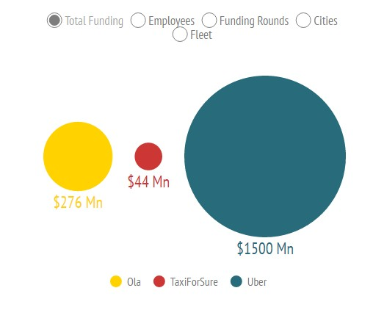 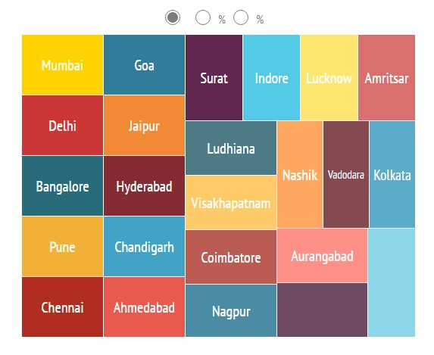

**Uber vs Ola vs TFS Pricing Delhi:**

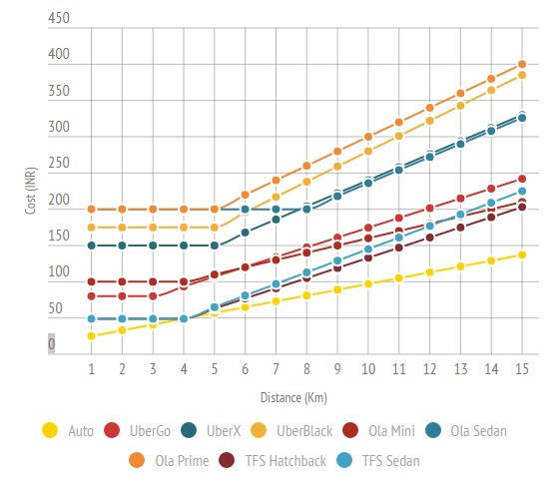

**Uber vs Ola vs TFS Pricing Mumbai**

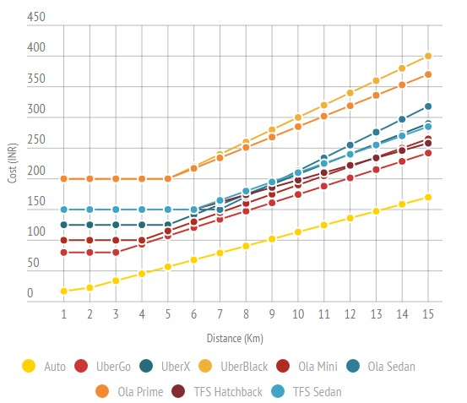

**Uber vs Ola vs TFS Pricing Bangalore**

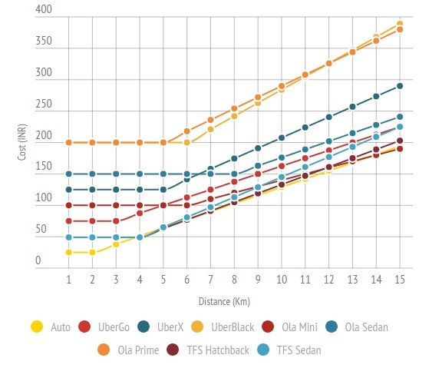

**Uber vs Ola vs TFS App Ranking**

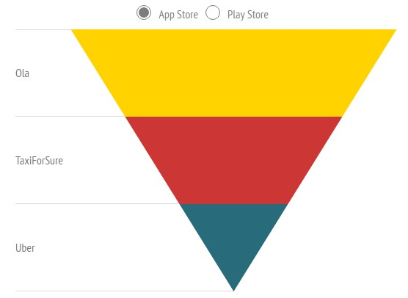

## Best App Features to Launch Online Cab Booking Platform

The car rental space in India has been going through near vertical growth for couple of years now. The sublime growth of online cab aggregators has seen many budding entrepreneurs start their own ventures with clone script. To help such entrepreneurs, analysts at FATbit technologies spent countless hours studying the functionality and business model of India’s largest online cab aggregators. Let’s learn about this business model, competitors, and most important features of the mobile app.

## Business model

Platforms like OlaCabs, Uber and Taxiforsure are basically a cab aggregators that partners with private cab operators to provide rides on request. The revenue model of such platforms is based on pay-for-performance, and it charges a commission from cab operators on every sale it makes. In addition to that, they also charge a nominal fee from operators for offering access to its technology platform.

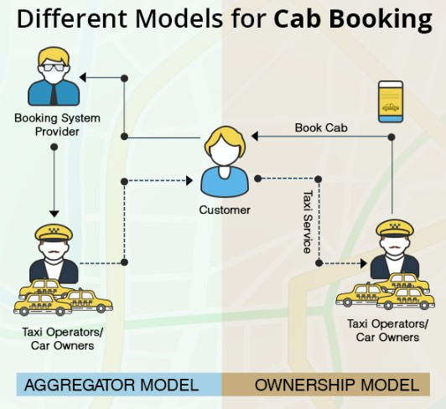 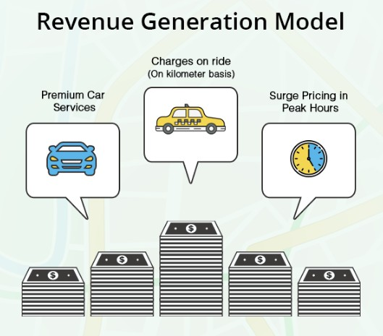

Main competitors

* Uber
* OlaCabs
* Taxiforsure
* MeruCabs
* BookCab
* TaxiGuide

The differentiator between your platform and other cab booking service can boil down to few points:

* You understand the Indian ecosystem and create policies with target audience in mind.
* Offer a wide array of booking methods like mobile app, website and phone call.
* Multi-mode payment options available to riders including cash payment. This mode of payment is preferred by Indian audience.

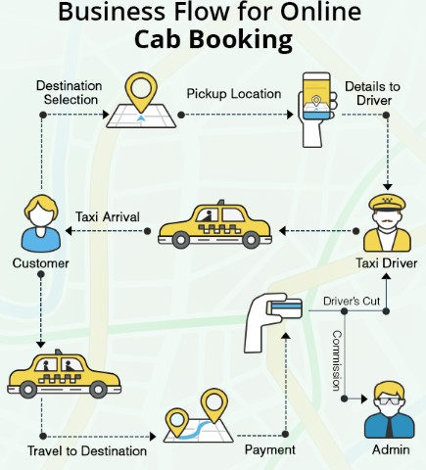

## Basic App Functionality

The online taxi aggregator app needs to be highly intuitive and offer an impressive layout. All the features of the mobile app should be well defined and focus ought to be on immersive behavior. The overall interface should be specifically designed keeping in mind the targeted user base and ease of use.

## User Guide

As soon as the user launches the application, he could come across a well-defined user guide. It covers each and every aspect of the cab booking process, making it easy for first time users to perform core tasks. Such guides are crucial to introduce app users to important mobile features and action process. Whether you are building a cab booking website or mobile application, don’t forget to make provision for UX rich user guide.

## Effortless Signup Process

The basic design architecture of your application is to keep everything simple and user friendly. The same should hold true for sign-up page. Before using the application, it is mandatory to have a registered account with the platform. The overall process should be minimalistic keeping in mind the mobile nature, and requests only most critical information such as:

* Name
* Email
* Password
* Mobile number

## User Centric Booking Process

After the completion of registration process, the users can be taken to the main screen where they can easily pick a ride for themselves. Here are the most noticeable points in the cab booking process:

* Search bar to enter a desired pickup location.
* GPS feature to detect current location.
* A detailed map to see their selected location.

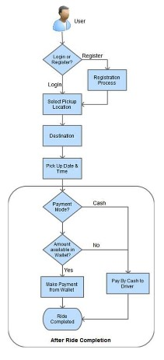

## Locations saving feature

User can also select and save their favorite location which can be accessed easily. This is beneficial in cases when you seek ride to or from a location on a regular basis. Features related to most frequented destinations and routes will add to app usability and makes cab booking easy for riders.

## Estimated time of arrival

As per services offered in the vicinity of the user, the application should show the options of choosing the cab along with their estimated time of arrival (ETA). This is highly beneficial feature as the user is made aware of the time frame from very beginning.

## Booking flexibility

After selecting the mode of transportation, user can choose between taking the ride right away or at a later time. This is useful for consumers who want to book a cab at a desired time, without undergoing the hassle of time-bound booking. More on this would be covered in the later stage.

## Cab confirmation

If the user chooses to book a ride right away, then, they are shown a confirmation screen which also has detailed information regarding the rate card and ride estimate. It also offers users to apply for discount via coupon codes. Pick an clone script that has cab scheduling and confirmation related features.

## Transparent booking process

One of the deciding factors that would make any online cab booking service a hit among users is the transparency in pricing.  All the information related to the fares should made available to the user in a clear manner. Using the option of rate card, users can view the fare breakup with respect to their chosen ride.

## Fare precision

As discussed before, you need to ensure that the consumers have all the relevant information beforehand related to the fare charges. The option available to the users in the form of “Ride Estimate” shows all the details related to the approximate time travel and the estimated cost to the user. Giving a clear idea of fare and pricing can help your clone score additional points.

## Advanced booking

For users who want to book the ride for a later stage, a pop-up box can be shown, where they can select the date along with the desired time. This is beneficial in cases of rush-hour when users sometimes find it difficult to find a cab.

## Ride details

Once the booking is confirmed, users are able to see the current location of the cab and the estimated time of arrival. Other details available are:

* Name of the driver
* Color and make of the car
* Registration number of the cab
* Contact details of the driver

User can also cancel the booked cab before the driver reaches the respective pickup point. This option can be used if there are any unavoidable changes in the user’s plan.

## Ride feedback

After reaching the destination, user can be prompted with the screen showing the total cost and distance travelled. With the focus on user engagement, the platform should request the users to give their feedback on the ride experience. This not only rates the driver for future reference, but helps the company in discovering the level of customer satisfaction. Integrate driver rating and feedback feature in your clone.

## Distinguishing features

Now that we are done with unique features that are part of the booking process, let’s have a look at features that make the app stand apart. Below are the features that can greatly help the cab booking company build brand identity in an otherwise competitive industry.

## My Rides

This feature shows the detailed list of all the bookings undertaken listing upcoming and well as completed rides. This helps in keeping track of all the rides booked by the user. While the completed section shows the history of rides taken, upcoming section gives preview of rides scheduled for future.

## Invite and Earn

Online cab booking services has gained huge momentum but concept is new to many users. In order to capture the overall market share, the platform can offer a referral program under which riders can invite their friends using a referral code and earn money. Users can send an invitation by SMS, email and also through social networking platforms like Facebook, Twitter and WhatsApp. Make sure your online taxi booking clone script has this feature!

## Rate Card

The platform needs to understand the market dynamics which calls for transparency in their overall functioning. This is the reason why it should offer a well detailed rate card to the consumers using which they can analyze the standard rates chargeable to them with respect to the destination as well as mode of transportation.

## Emergency Contact

In order to ensure safe and hassle-free rides, the platform should provide a security feature in their application where users can add contact details of any person. Moreover, the user can also opt in to share information with that emergency contact every time a ride is taken. This is one feature you must not miss in your clone if you want to operate in Indian market.

We covered all the features in above sections, and have to say that most of them are rather innovative. Additionally, our team of analysts and developers has discovered some areas that can help you in creating an advanced taxi aggregator clone. Here they are!

## Emergency button

You can offers an emergency button in the application which sends the ride details as well as current location to a pre-defined contact in case of emergency. This is highly vital security feature and can boost user confidence.

## FAQ Section

## Frequently Asked Questions (FAQS)

### 1: Where to find a good driver for this business?

Well finding a good driver for this business is pretty tough but if you look at a driver into some small towns then you can easily get a good driver with less salary requirement.

### 2: Can you hire two drivers for a single car?

The answer is yes; you can put two drivers for a single car, and this idea will increase your profit in this business. All you need is to divide job time for both of the drivers.

### 3: How to get a commercial license for Cabs business?

Ola & Uber, both of these companies, will help you to get a commercial license as fast as possible. All you need is to contact them, and they will guide you on each and every step.

### 4: How much you can earn as profit?

If your driver was giving 336 hours in a month which is almost 11 hours per day, then you can easily earn up to 30k to 40k including all incentives and bonuses.

### 5: What are the things cab driver should know before starting this job?

You have to train your driver to use cab’s mobile application and how to track ride order through gaps. Also, you have to make him learn to treat all the customers with good behaviour so that you can be good ratting by your customers which as a result increase your future orders.

### 6: Can you attach your cars with two cabs companies?

Well, answer is pretty straight forward to yes. You can easily attach your single car with so many cabs companies, but you have to make sure while completing a ride order, you need to switch off all other devices and safe yourself from money deduction. If you cancel or do not show any response to next ride order, then money automatically deduct from your account for not taking the order as fault fee.

### 7: Which car you should buy for this business?

-: Tata Etios

-: Maruti Swift Dzire

-: Maruti Swift

-: Tata Indica

-: Nissan Sunny

-:Nano

-: Toyota Innova

# Some focus areas to become successful

* Get a mobile Application. It is must and a necessity for this industry.
* Look for Professional and skilled drivers. One bad driver can let your image down
* Before entering market, build your taxi base so as to meet the demand.
* Ensure customer reach: Your taxi services should be available at maximum places in city.
* Minimum waiting time: Less the waiting time, more happy customer
* Multiple Payment Methods: User should be able to pay through online wallet and also by cash if they want.
* Online Documentation creation services can be a good add-on but need to be aware of every target market in detail because laws differ from place to place.

# Build the next billion dollar cab booking company

The Indian Taxi market is worth around $8 billion out of which only 5% is managed by organized sector. This means there is enough space for clones. If you are planning a cab booking platform, then you cannot afford to miss out on these features. Make your prospects in cab booking system brighter by incorporating new features in your clone.

Discuss your mobile application requirements with a team of UX designers and developers to launch a successful online taxi booking clone.

**Current Scennario**

**Raw Money Power:**  
Looking at the lack of adequate public transport in Indian cities, [Ola](http://www.businessinsider.in/searchresult.cms?query=Ola&sortorder=effectivedate) and [Uber](http://www.businessinsider.in/searchresult.cms?query=Uber&sortorder=effectivedate) have together promised an hefty investment of over $2.25 billion in India.  
  
[Uber](http://www.businessinsider.in/searchresult.cms?query=Uber&sortorder=effectivedate) reportedly plans to pump over $500 million by June in India. This is over and above the $1 billion already committed over the past nine months. That is some serious money.  
  
[Ola](http://www.businessinsider.in/searchresult.cms?query=Ola&sortorder=effectivedate) hasn't been left wanting either. It has promised to add another 2,000 cars to its existing fleet of 26,000 in the nation's capital. It is backed by the likes of [SoftBank](http://www.businessinsider.in/searchresult.cms?query=SoftBank&sortorder=effectivedate), and some of the most cash-rich VCs in the world.  
  
**WiFi in Autos?**  
[Ola](http://www.businessinsider.in/searchresult.cms?query=Ola&sortorder=effectivedate) and [Uber](http://www.businessinsider.in/searchresult.cms?query=Uber&sortorder=effectivedate) both began offering in-car WiFi last year.  
However, [Ola](http://www.businessinsider.in/searchresult.cms?query=Ola&sortorder=effectivedate) has been pulling out all its stock to go up against [Uber](http://www.businessinsider.in/searchresult.cms?query=Uber&sortorder=effectivedate). The company plans to launch WiFi services in the budget cab segment, and even its auto-rickshaws.  
Some wonder how that's humanly possible at the current cost.  
  
**Legal Battles:**  
Interestingly, both taxi aggregators have been in legal wrangles.  
  
In October 2015, [Ola](http://www.businessinsider.in/searchresult.cms?query=Ola&sortorder=effectivedate) filed a legal petition, accusing [Uber](http://www.businessinsider.in/searchresult.cms?query=Uber&sortorder=effectivedate) of flouting a Supreme Court order demanding app-based taxis in New Delhi switch from running on diesel to using CNG (compressed natural gas).  
  
A few months on, [Uber](http://www.businessinsider.in/searchresult.cms?query=Uber&sortorder=effectivedate) recently sued [Ola](http://www.businessinsider.in/searchresult.cms?query=Ola&sortorder=effectivedate) for allegedly creating 93,000 fake [Uber](http://www.businessinsider.in/searchresult.cms?query=Uber&sortorder=effectivedate) accounts, and tampering its businesses. The company has been seeking around $7.4 million in damages.  
  
[Uber](http://www.businessinsider.in/searchresult.cms?query=Uber&sortorder=effectivedate) claims [Ola](http://www.businessinsider.in/searchresult.cms?query=Ola&sortorder=effectivedate) employees used bogus accounts to book and cancel a whopping 400,000 rides over the last six months.  
  
[Uber](http://www.businessinsider.in/searchresult.cms?query=Uber&sortorder=effectivedate) allegedly had to pay high cancellation charges to drivers due to this. It claims around 20,000 drivers quit the platform in frustration.  
  
[Ola](http://www.businessinsider.in/searchresult.cms?query=Ola&sortorder=effectivedate) officials 'categorically deny' [Uber](http://www.businessinsider.in/searchresult.cms?query=Uber&sortorder=effectivedate)'s allegations of fraud. Senior officials Anand Subramanian and Rahul Maroli told Business Insider they 'stand by' their statement.  
  
**Accusations:**  
Both Ola and Uber have been accused of wrong-doing.  
  
Recently, [Paytm](http://www.businessinsider.in/searchresult.cms?query=Paytm&sortorder=effectivedate)-backed online transportation app [Jugnoo](http://www.businessinsider.in/searchresult.cms?query=Jugnoo&sortorder=effectivedate) alleged Ola has adopted unethical practices against it. In a blog post, the company claims Ola employees made fake bookings, and tried to hamper its operations.  
  
[Jugnoo](http://www.businessinsider.in/searchresult.cms?query=Jugnoo&sortorder=effectivedate) CEO Samar Singla has said his team saw a sudden surge in bookings and cancelations. According to him, around 20,000 cancelations were made through 800 accounts over a 10-day period earlier this month. In December, the auto-rickshaw aggregator had accused Ola of poaching employees and driver database in Chandigarh.  
  
Uber has made similar claims against Ola. Ola spokesperson [Anand Subramanian](http://www.businessinsider.in/searchresult.cms?query=Anand+Subramanian&sortorder=effectivedate) maintains this to be Uber's way of 'payback' for the legal petition Ola filed, accusing Uber of flouting a Supreme Court order.  
  
Interestingly, Uber's rivals [Lyft](http://www.businessinsider.in/searchresult.cms?query=Lyft&sortorder=effectivedate) and [Gett](http://www.businessinsider.in/searchresult.cms?query=Gett&sortorder=effectivedate) had in 2014 complained against the aggregator of making false bookings, and recruiting Lyft and Gett driver partners for its own service.  
  
**Experiments gone wrong:**  
In an attempt to find new battlegrounds, Ola and Uber both launched their bike-taxi services in India's Bengaluru on the very same day.  
  
It seems both knew of each other's plans and neither wanted to be left behind. However, neither was fully ready. Several users claimed not a single bike taxi was visible.  
  
Both were offering extremely competitive rates. Ola has a per km rate of Rs 2, and a minimum fare of Rs 30. Uber has a per km rate of Rs 3 and a minimum fare of Rs 15.   
  
However, Ola was forced to roll back its service a few days later after the Karnataka state government said that India's Motor Vehicle Act doesn't have a provision for two wheelers to be used as taxis. Simply put, the bike taxi services were illegal.  
  
When asked about the same, Ola COO Pranay Jivrajka refused to comment on the issue.  
  
However, Uber bike taxis continue to ply on Bengaluru's (earlier Bangalore) roads.  
  
This isn't the first time this has happened. As rival Uber was turning up the heat, Ola started experimenting with hyper-local food and grocery delivery.  
  
It was later forced to shut these and focus on serving its core business. Although, it went on an overdrive, introducing new categories like Micro, Prime, a shuttle bus service and carpooling in a very short span.  
  
**Regulatory hassles:**  
While Uber has been facing regulatory hassles worldwide, and has the muscle to lobby for friendlier policies, Ola is still pretty new to such complications in business.  
  
Recently, Indian state Karnataka stood firm on not allowing surge pricing for app-based ride hailing services such as Ola and Uber. In the state, online taxi aggregators operate as ride-hailing service under a license obtained under the Radio Taxi Scheme, 1988.  
  
The policy says the charged fare cannot be higher than the fare fixed by the government. That means transport apps have to charge within a band where the upper limit is capped. Ola COO [Pranay Jivrajka](http://www.businessinsider.in/searchresult.cms?query=Pranay+Jivrajka&sortorder=effectivedate) told BI the company's 'working together' with the state government to find a feasible solution.  
  
Way back in August, in a major setback to Ola Cabs, the Delhi High Court dismissed its plea challenging a single-judge order upholding Delhi government's ban on such taxi services.  
  
While Ola argued that non-app based taxi organizations also come under the Radio Taxi Scheme, and that Ola doesn't own these vehicles anyway, the Delhi government had said the All India Tourist Permit (AITP) vehicles that operate under Ola brand are meant for tourist destinations and not point-to-point service in city.  
  
Online taxi aggregators were finally legalized.  
  
**Chest Thumping**  
Ola and Uber have both thrown around numbers that hardly make sense if put together.  
  
In a recent interview, Ola's Chief Marketing Officer and Head of Categories Raghuvesh Sarup said, "In three weeks, we have put up a category (Ola Micro) which is already 50% of all of Uber's daily bookings in the country. The rate at which Micro is growing, it will be larger than their entire brand within a month."  
  
On the other hand, Eric Alexander, President of Uber's Asia business, in an interview said his company was on the verge of overtaking Ola in India. "In January last year, we were at five per cent market share. Now, we are right at the edge of 50 per cent. Within next 30 days, we would beat them (Ola). We will surpass them very, very shortly."

**Benefits:**

1. We can hire two or more drivers for your single car which be a very good idea to increase your business profit. You can divide time for each of your driver so that they can easily put their full efforts in order to complete more rides in a single day like if you have two drivers then its nice,. drive 1 can work in ola. and driver 2 work on uber. both side if you archive the target.. you have good bonus, so you can pay both drivers a very good salary..

2. Driver Salary depends on the city as in the Bangalore it is around 9-10k per month with working hours of 13-15.But if you find a driver near to Delhi side then they will take around 8-9k per month. As you can see driver salary totally depends on the driver's own choice, it is not fixed salary yet for drivers. If you able to find a trusty driver from a small town then he surly can work for you on 6-7k average salary per month.It also depends on you how you manage your own driver.

3. In order to ensure safety to its passengers [Uber](https://inc42.com/tag/uber) has announced that it has partnered with [First Advantage](http://www.fadv.com/) for driver screening. “This is an important step in building out an industry first background check process for every one of the thousands of driver-partners on the Uber platform in India.” The step has been taken after the [alleged](http://inc42.com/buzz/trouble-continues-uber-woman-raped-delhi-file-petition-us-court/) rape of the women passenger by the Uber driver.

First Advantage is a global leader in background screening that has worked with about 45,000 organizations worldwide processing over 23Mn screens annually, according to its website.

**Different problems with transportation:**

**Problems faced in ola and uber illegality:**

In new dehli ola and uber are operating illegally in the city, "illegal operations" of these "unlicensed" aggregators.  
This led to a shortage of cabs in the midst of the second phase of odd-even, inconveniencing commuters who had found it to be a good option.

2. Taxi hailing firms like Uber, Ola and states haggle over dynamics of fare game:

NEW DELHI & BENGALURU: A frequent customer of [Uber](http://economictimes.indiatimes.com/topic/Uber) in Bengaluru received an email from the taxi-booking company last week titled 'Why pay more for a less reliable ride?'.

Based on his usage data, Uber calculated that under the Karnataka government's newly determined rates for taxis he would have had to pay an additional Rs 16,000 for about 120 rides taken since January—that is, about Rs 38,000 instead of Rs 22,000.

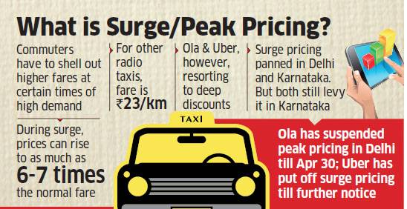

The companies argue that theirs is a free-market practice based on demand and supply to ensure their cabs are available at all times and that their prices are far more competitive than the government-determined rates for taxis—explanations rejected by the state governments and several others who perceive surge pricing as hugely exploitative.

"During the last odd-even phase in Delhi (January 1 to 15), 92% of the trips were regular fare and only 8% were at surge fare," a spokeswoman for Uber India said. "And the surge fare averaged less than 2 times the normal fare."

**a**. Cries in support of the Delhi and Karnataka governments' decisions are equally assertive, with several of those opposing surge pricing arguing that all companies should follow rules uniformly. Rival taxi operator Meru has openly sided with Kejriwal's fight against dynamic pricing, saying the right way for Ola and Uber to solve the problem would be to [invest](http://economictimes.indiatimes.com/topic/invest) in adding more taxis to their platforms and serving customers on a first-come-first-serve basis.

"When the poor guys (auto-rickshaw and individual taxi drivers) charge a premium for a ride, people blame the government for not taking any action," said Siddhartha Pahwa, chief executive of Meru. "(With Uber and Ola), there is no way of checking or validating the dynamic pricing algorithm written by these companies."

Uber and Ola do not share the formula they use for their fare multipliers.

"When there is going to be a monopoly, then the same taxi aggregators can charge 10 times the price," Pahwa said. "Then who will take care of the general public's interest."

3. Uber has filed a case against its Indian competitor Ola, accusing it of creating fake bookings on the former’s platform and later cancelling them, thereby misleading drivers and causing loss to the U.S-based company.

# 4. India Asks For Blocking Uber, Ola Websites But It Is Just Not Possible

The communication ministry, after consulting its two wings - the department of electronics and IT and the department of telecommunications (DoT), which provide licences to internet service providers (ISPs) - replied that it did not have the capacity to restrict the availability of social media in a particular area, but had the option to block Twitter throughout the country.

"We cannot put a filter for websites of Ola and Uber as they are based on https and are highly encrypted. But we have blocked TaxiForSure, which is on http,

Http stands for hyper text transfer protocol, whereas the https means hyper text transfer protocol (secure). The difference between the two can be understood from the fact that most of the banking sites and e-mail service providers use https for secure transactions and exchange of information.  
Experts say access to a website or application can be restricted either at its origin or at the international gateway. Since the servers for most of the websites and applications are located outside India, neither the government nor the ISPs have the rights and expertise to block it. What best can be done is to restrict the content or website at the international gateway in Mumbai.  
  
However, the catch is if the restriction is applied at the international gateway, the entire country will not be able to access these websites and mobile-based applications. It means taxi aggregators Ola and Uber, which are operating without a licence, will continue to work without any problem in the national capital, because they have not been banned nationally.

Some argued that if the ISPs cannot filter these web-based applications, then the government should go the other way around. It should block internet protocol (IP), a unique number assigned to each computer or laptop, from accessing these applications. For instance, an Uber user in the national capital should be denied permission to its website and mobile application.

"Uber and Ola are part of a larger issue. There are many foreign websites, which are very popular in India, but we don't have any sort of control over them. We had suggested enacting a law that will force all websites and web-based applicants to set up their servers in India. But nothing has move in this direction, too," says the security official quoted above.

5. Sometimes there may not be a proper internet connection where the customer wants to end the ride, chances are that ride may not show up.

6. Traffic police Sue's them for wrong parking or taxi driver badge issues.

7. sometimes they had to drive from end of the city to the other end of the city for a single ride.(Because they get more money for more rides, like bonus).

8. They get very bored if they don't get a ride(usually 10am-4pm).

9. And traffics sucks after 4pm so it takes more time for them to drive through.

10. Another day, a lady placed a request to “Pick me up” from the Olacabs Android app, and received an sms instantly. When the driver didn’t call back for 10 minutes, she called him, and was told that his shift was over! She cancelled the request and placed another, to be allocated the same out-of-shift driver. She had to then call the office and book another cab, but not before painstakingly explaining to them why had she to cancel her previous bookings. And there were follow up calls about the cancellation, asking the same questions over and over again.

11. A big challenge was and remains is maintaining the supply. Drivers will just log off from their devices and do personal bookings in peak seasons leading to a lot of rejects for customers. The industry here is not just about keeping customers happy but keeping your supply happy as well.

12. In order to succeed in this fiercely competitive market, the taxi-booking companies should accommodate more bookings, have better safety measures, ensure proper training of drivers and offer attractive deals to tap the growing base of users in India.

**Advancement**

**Live camera and Recorder:**

Advanced Taxi Camera - Vehicle Black Box Camera simultaneously captures both front and interior views (dual view car camera) as well as audio, GPS data and G-Force monitoring. Simply power the taxi cam with the cigarette lighter adaptor and the unit will automatically begin recording. The interior view camera offers infrared lighting for low light conditions. Firmware supports up to 16 GB SD cards which will provide extended recording capabilities. Overall best value for a complete vehicle monitoring solution.

**Features:**

* No monthly fees.
* Locked MP4 file format to prevent tampering.
* Compact integrated single black box.
* Light weight advanced design.
* Quick and easy installation.
* Windshield mount for best vantage point.

**Uses:**

* Video document driving conditions.
* Record passenger actions.
* Capture events of an accident.
* Record road rage or aggressive motorists.
* Justify driver actions.
* Prove route taken by driver.
* Substantiate delays.
* Increase driver awareness.
* When Drivers know they are being monitored they tend to become more aware of their driving habits. This increased awareness may lead to improved fuel economy, safer driving habits reducing accidents and improved passenger relations. The Taxi Vehicle Black Box Camera may improve your bottom line and help to protect your taxi assets on the road.
* Passengers tend to feel safer when cameras are present and also tend to be kinder and less abusive towards drivers. Capturing video and audio documentation eliminates any doubt about what occurred inside and outside of your taxi.  A happy passenger in your taxi is more likely to request your company on subsequent needs.
* Often times a taxi driver or taxi company is the target of insurance fraud, claims of sexual harassment and other unfounded legal action. Having the facts documented may help to reduce your insurance liability and prevent wrongful unfounded accusations. With the current economic conditions, taxi owners and taxi companies are looking for ways to improve their bottom line while keeping their drivers safe and passengers happy.
* The taxis vehicle black box camera provides critical driving information in an advanced low cost recording system.

**Traffic Congestion:**

The launch of a slew of startups in the vehicle aggregation space, from taxis to buses and bikes, was expected to help the common man get access to relatively cheap, safe and reliable transport options. But run-ins with authorities in different cities has halted developments on that front.  This is especially true in the space of bus aggregation, which would have helped the most number of people.

There are many Advancements which we should compete all other Taxi Aggregrators...